

A Project Report

On

**IoT-ECG Fusion: Real-time Arrhythmia Classification with Optimized Deep Learning for Remote Cardiac Monitoring**

Batch Details

|  |  |  |
| --- | --- | --- |
| Sl. No. | Roll Number | Student Name |
| 1 | 20201CAI0175 | CHINTA DEEKSHITH REDDY |
| 2 | 20201CAI0198 | JAJALA REDDYRAHUL |
| 3 | 20201CAI0209 | JALA SRINATH |
| 4 | 20201CAI0210 | CHEREDDY JAYA SREEKAR REDDY |

**School of Computer Science,**

**Presidency University, Bengaluru.**

Under the guidance of,

Mr. Afroz Pasha

School of Computer Science,

Presidency University, Bengaluru

**CONTENTS**

1. Introduction about Project
2. Literature Review
3. Objectives

## Methodology

1. Timeline for Execution of Project
2. Expected Outcomes
3. Conclusion
4. References
5. **INTRODUCTION**

ECG (Electrocardiogram) is a medical test that records the electrical activity of the heart over a period of time using electrodes placed on the skin1. Arrhythmia is a condition where the heart beats irregularly, either too fast or too slow1.

ECG graphs can be used to detect arrhythmia. Researchers have developed various machine learning models to classify ECG signals and detect arrhythmia. For example, a 12-layer deep 1D Convolutional Neural Network (CNN) has been proposed for better feature extraction1. Another study proposed a novel multimodal deep fusion and hypered architecture that makes use of CNNs based on ECG for arrhythmia classification2.

These models use CNNs (Convolutional Neural Networks) to analyze ECG signals and classify heartbeats. The models are trained on large datasets of ECG signals to learn the patterns of normal and abnormal heartbeats. Once trained, the models can be used to classify new ECG signals and detect arrhythmia.

1. **LITERATURE REVIEW**

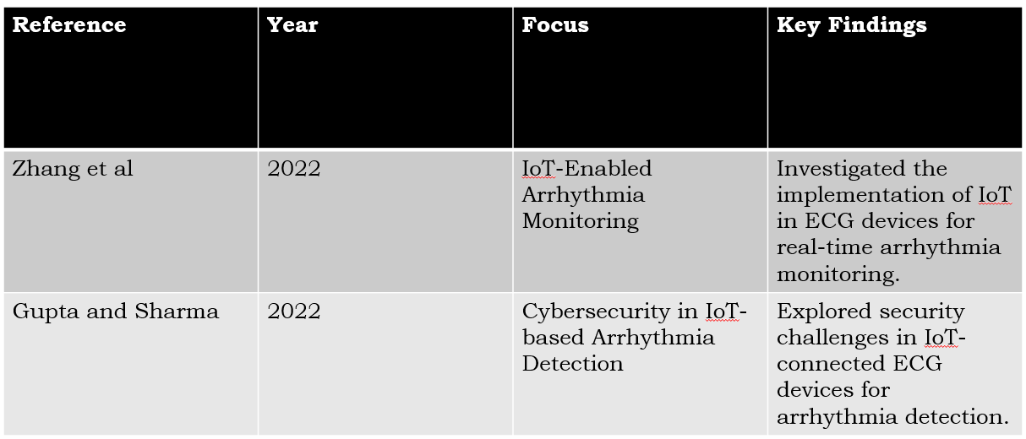

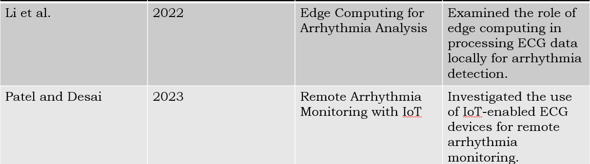

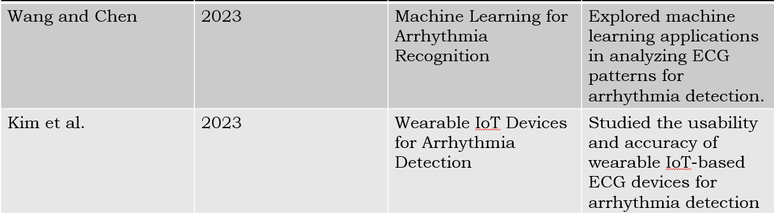

**3.OBJECTIVES**

The objective of this study is to use a hybrid model that combines IOT and CNN to improve

classification performance of arrhythmia beats I found a recent review paper on arrhythmia detection and classification using ECG and PPG techniques . The paper provides an overview of state-of-the-art methods, including preprocessing, feature extraction, and classification techniques for the detection of various arrhythmias. The review also highlights various wearable sensors used in the literature and public databases available for the evaluation of results. The study also highlights the limitations of the current techniques and pragmatic solutions to improvise the ongoing effort.

The objective of the study is to provide an overview of the current state-of-the-art methods for arrhythmia detection and classification using ECG and PPG techniques. The study aims to highlight the various wearable sensors used in the IOT to read the data of the heartbeat. The study also highlights the limitations of the current techniques and pragmatic solutions to improvise the ongoing effort.

In addition to the review paper, researchers have proposed various machine learning models to classify ECG signals and detect arrhythmia. For example, a 12-layer deep 1D Convolutional Neural Network (CNN) has been proposed for better feature extraction. Another study proposed a novel multimodal deep fusion and hypered architecture that makes use of CNNs based on ECG for arrhythmia classification. These models use CNNs to analyze ECG signals and classify heartbeats. The models are trained on large datasets of ECG signals to learn the patterns of normal and abnormal heartbeats. Once trained, the models can be used to classify new ECG signals and detect arrhythmia.

**EXPERIMENTAL DETAILS/METHDOLOGY**

The pulse data is collected using the Pulse sensor using the Pulse sensor libraries in the Arduino IDE. The analog pulse values and the BPM data are collected from the pulse sensor and this data is collected and sent through Arduino Uno to the NodeMCU by using [serial communication](https://www.sciencedirect.com/topics/engineering/serial-communication) protocols. The NodeMCU is connected to the ThingSpeak platform and the data points are uploaded to the respective fields in a particular channel.

In below figure-1 system diagram: The pulse sensor's analog pin is connected to the analog input A0 of Arduino Uno. And the VCC and GND of the pulse sensor is connected to the respective inputs on the Arduino Uno. NodeMCU.

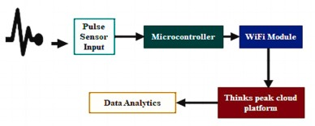figure -1

1. **Hardware:**

A tiny Raspberry Pi is used with high specifications. It has a quad-core, 32-bit CPU with 40 pins that operates at 900 MHz. It has four USB ports, one gigabyte of memory (RAM), an Ethernet connection, a micro-SD port for storing the operating system and other files, and a low-power 5 V, 2 A power supply.

### **System design:**

The given model and circuit in figure 2, can be used together to detect Cardiac Arrhythmia. The data is exported to the Thingspeak website using IoT Our research involves usage of Pulse sensor. Pulse Sensor is integrated with the buzzer. When the bpm (bulse per minute) of an individual is higher than the normal acceptable limits it indicates the user by buzzing thereby alerting the individual to slow down or take rest. The model and circuit are as follows:

•The Pulse Sensor is connected to the Arduino Uno board.

•The Pulse Sensor is used to measure the heart rate of the individual.

•The Arduino Uno board is used to analyse the data from the Pulse Sensor and detect Cardiac Arrhythmia.

•The Arduino Uno board is connected to the Thingspeak website, which is used to store the data from the Pulse Sensor and plot it in a graph.

•The Arduino Uno board is also connected to a buzzer, which is used to alert the individual if the bpm is higher than the normal acceptable limits.

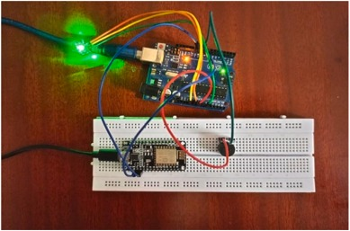

Figure-2

ECG AND ARRHYTHMIA

The heart is made of tissue that periodically polarizes and depolarizes resulting in pumping of blood across the body. A normal cardiac cycle consists of depolarization and repolarization cycles of the heart muscles leading to variation in electrical activity, which can be measured. The non-invasive cardiac diagnostic tool Electrocardiogram (ECG) is a graph of this electrical activity. A conventional ECG is measured by ten electrodes placed on the skin, which form 12 leads that record the heart activity from different views. By studying the ECG waveform, experienced cardiologists can determine if the heartbeat is healthy or abnormal. The latter case is called arrhythmia and can be usually detected due to abnormalities in the waveform. Arrhythmia leads to irregular electrical activity which manifests itself in the ECG. We describe the ECG signal and different types of arrhythmia in the next sub-sections.

A. The ECG signal

In Figure 1, a normal ECG waveform depicting a single heart beat is shown. We have voltage on the y-axis and time on the x-axis. The morphology of the ECG wave consists of

2 various components and the intervals between them .The first is the P-wave, which depicts atrial (upper heart chambers) depolarization or activation. The P-wave is the first bump on the left. The PR interval is the time interval from the beginning of the P-wave to the beginning of the QRS complex. The line from the end of the P wave to the beginning of the QRS complex is the PR segment. The next is the QRS complex which shows depolarization of the ventricles (lower heart chambers). The length of the QRS complex is the QRS

duration and the peak amplitude is called the R peak, which is an important reference point for the whole signal. A short QRS duration indicates a healthy heart since it means that the

ventricles have depolarized and have quickly become ready for the next cycle. A long QRS duration means the heart is sluggish. The time interval between two successive R peaks,

called the R-R interval, is a very crucial factor used by most studies in ECG analysis. The next part is the ST segment which indicates the second part of the activation, followed by the T wave showing complete repolarization (recovery of ventricles).

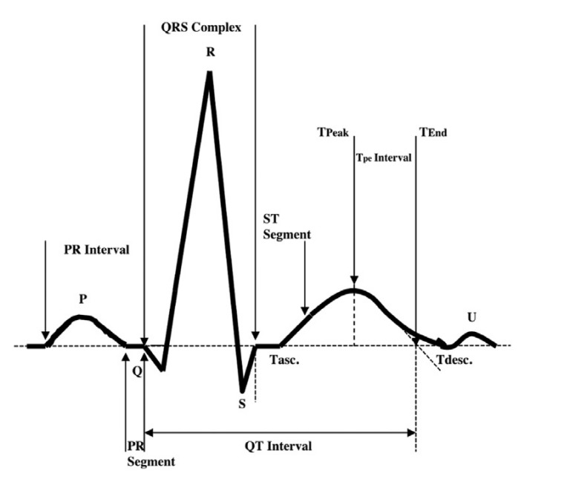

B. Types of Arrhythmia

The association for the advancement of medical instrumentation (AAMI) classifies non-life-threatening arrhythmias into non-ectopic (N), supraventricular ectopic (S), ventricular

ectopic (V), fusion (F), and unknown (Q) ( [20], [21]). Most of the studies listed in this review classify ECG beats into these five common classes.

### **3.Data sets:**

The MIT-BIH Arrhythmia database is a widely used database for evaluating algorithms for ECG analysis and classification. In figure-3, contains ECG recordings from two institutions: the Beth Israel Hospital (BIH) in Boston, Massachusetts and the Massachusetts Institute of Technology (MIT). The database consists of 48 half-hour recordings of two-channel ECG signals, with a total of approximately 5 min of annotated ECG waveform data. The recordings were taken from patients with a variety of heart conditions, including arrhythmias, and the database is commonly used for research in ECG signal analysis, arrhythmia detection, and classification. The database is publicly available for non-commercial use and is widely used as a benchmark for evaluating the performance of ECG analysis algorithms.

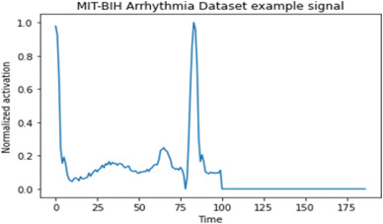figure-3

In real-world scenarios, valuable signals typically appear as low frequency or more smooth signals while noisy signals typically

appear as high-frequency signals in signal processing. The high frequency wavelet coefficients are obtained from the signals with

noise when the signals are divided by the wavelet transform. Then,

high-frequency wavelet coefficients are threshold processed to

remove interference from power lines and electromyography.

Finally, the inverse wavelet transform is used to reconstruct signals.

1. **CNN Model Architecture :**

Different manually created features are used by traditional

machine learning techniques to obtain representations of input

data. Deep learning involves an autonomous learning process that

progresses from low-level representations acquired over numerous

layers to higher abstract representations.

One of the most popular varieties of artificial neural networks is

the CNN. A CNN is conceptually similar to a multilayer

perceptron (MLP). When the network contains more than one

hidden layer, an MLP becomes a deep MLP. Since each perceptron

in MLP is interconnected with every other perceptron, there is a

risk that the total number of parameters will increase significantly.

Due to the large degree of redundancy, this is inefficient. Its

disregard for spatial data is another drawback.It accepts inputs of

flattened vectors. These issues were fixed by the CNN model by

accounting for local connection. Additionally, all layers are

somewhat loosely rather than completely attached.

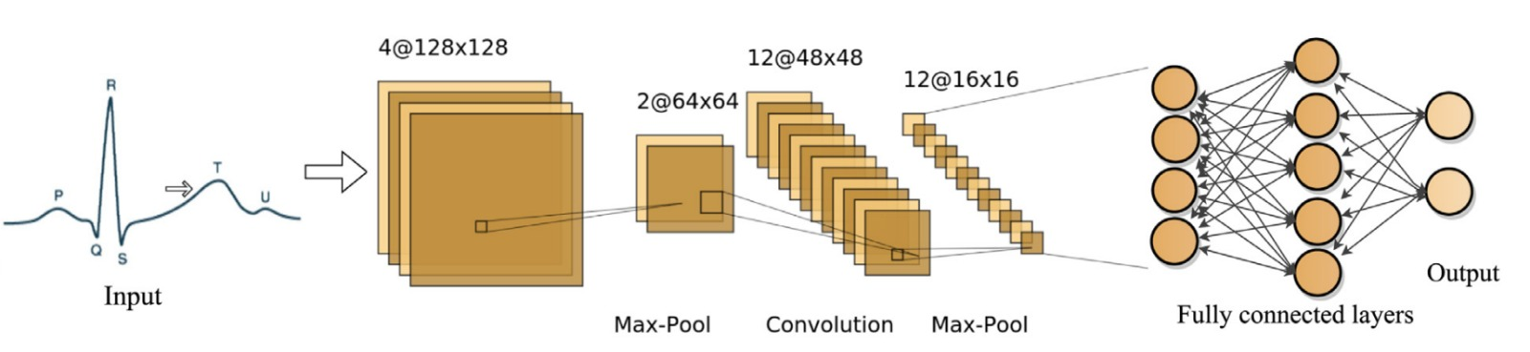

The convolution layer, pooling layer, and fully-connected layer are the three fundamental layers of the CNN architecture. It also consists of two parts: a feature extractor that automatically learns

the features from the raw input data, and a fully integrated multilayer perception system (MLP). The convolution layer and the pooling layer are the first two layers of the feature extractor. The

input is scanned in terms of dimensions by the first layer, which also utilizes filters and convolution processes. The stride and filter size are two of its hyper-parameters. The output is added by a bias

before being subjected to the activation function to create a feature map for the following layer. This output is known as a feature map or activation map. As the beat samples data input vector, let x0i =

[X1, X2....Xn], where n is the number of samples per beat.

The output of the convolution layer is:

cl,j =σ(b +ΣM wj x0j ),

where wmj is the weight for the jth feature map and mth filter index, l is the layer index, is the activation function, b is the bias term for the jth feature map, M is the kernel/filter size. The

pooling layer comes just after the convolution layer. It is a process of down sampling. It helps to shrink the size of the activation map, which produces medium-level features. A layer's pooling of a

feature map is determined by

Pl,j =max r∈R(cl,j i i×T+r )

where T is the pooling stride and R is the pooling window's size. The fully connected layer is the final layer (FC). It uses a flattened input where all neurons are coupled to each input. An activation

function, a mathematical equation that defines a neural network's output, was used in each neural network. Each neuron in the network has a function connected to it that decides whether or not

to activate it based on whether the input from that neuron is important to the prediction made by the model. ReLu serves as an activation function in this investigation. Considering For many different kinds of neural networks, it has evolved into the standard activation function. There isn't any difficult math.

As a result, the model can train or run faster. It is described mathematically as y = max (0,x). The appearance is similar to A straightforward softmax classifier is utilised for beat classification and is 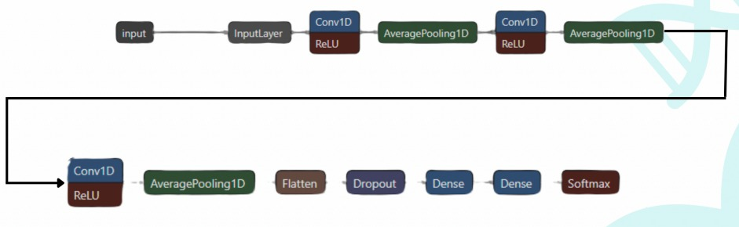

positioned at the end of the CNN design.It is a mathematical function that turns a vector of integers into a vector of probabilities, where the probabilities of each value are inversely correlated with their relative sizes in the vector. The prediction error is determined using the loss function when the predicted output is obtained through forward propagation. Back propagation is then used to update weights by computing the gradient of the convolutional weights. The projected error propagates back on each parameter of each layer during this process. The propagation process is continued both forward and backward until a certain number of epochs are reached.An important factor influencing the final classification and recognition results is the deep learning network's depth. The general concept is to make the neural network design as deep as possible. Increasing the depth will eventually hurt the deep learning network's performance though. Vanishing/exploding gradients is a problem that makes network training more challenging. The residual block was used to overcome this difficulty. It is a stack of layers configured so that each layer's output is added to a layer further down the stack. By using "shortcut connections" that skip numerous network layers, it is an enhanced deep learning algorithm for CNN that prevents these issues.The two convolutional layers in the proposed model make it better than the model that was first put forth in. I added the two layers in a residual block to get around the aforementioned problem. The input layer of our suggested model architecture is composed of a segment of ECG data with 180 sample points. It has two convolutional layers, two pooling layers, two fully connected layers, and one softmax layer. The kernel sizes, strides, and

number of filters on each layer are three, two, and eighteen, respectively. Reversed linear function (ReLu) was used after each convolutional layer. A residual block with two convolutional layers exists (18 convolution kernels with a length of 7 and stride 2)

1. **OUTCOMES**

**6. TIMELINE OF THE PROJECT/ PROJECT EXECUTION PLAN**

1. **Project Initiation**

3 to 4 days

1. **Literature Review**

15 days

1. **Data Collection and Preprocessing**

15 to 20 days

1. **Model Design and Development**

10 to15 days

1. **Testing and Validation**

10 to 15 days

1. **Documentation and Reporting**

15 days

1. **CONCLUSION**

In conclusion,we propose a neural network, ABCNN, for heart arrhythmia detection. The model integrates the advantages of multi-head attention mechanism and convolutional network. We design an attention layer that encourages the model to focus on the most informative ECG signals. We adopt convolutional layers to automati features from the input raw EEG data. In order to evaluate the validation of the proposed model, we conduct extensive experiments over a benchmark dataset for heart arrhythmia diagnosis. Our approach achieves the highest AUC for the arrhythmia diagnosis, outperforming widely used baselines. The experimental results show that ABCNN is effective and efficient in heart arrhythmia detection.

**REFERENCES**

1. T. Soman and P. O. Bobbie, “Classification of arrhythmia using machine learning techniques.” WSEAS Transactions on computers, vol. 4, no. 6, pp. 548–552, 2005.
2. S. Chauhan and L. Vig, “Anomaly detection in ecg time signals via deep long short-term memory networks,” in Data Science and Advanced Analytics (DSAA), 2015. 36678 2015. IEEE International Conference on. IEEE, 2015, pp. 1–7.
3. B. Hou, J. Yang, P. Wang, and R. Yan, “Lstm-based auto-encoder model for ecg arrhythmias classification,” IEEE Transactions on Instrumentation and Measurement, vol. 69, no. 4, pp. 1232–1240, 2019.
4. A. Hossen and B. Al-Ghunaimi, “Identification of patients with congestive heart failure by recognition of sub-bands spectral patterns,” in Conf Proc of World Academy of Science, Engineering and Technology, vol. 34. Citeseer, 2008, pp. 21–24.
5. A. Schumann, N. Wessel, A. Schirdewan, K. J. Osterziel, and A. Voss, “Potential of feature selection methods in heart rate variability analysis for the classification of different cardiovascular diseases,” Statistics in medicine, vol. 21, no. 15, pp. 2225–2242, 2002.
6. J.-c. Hsieh and M.-W. Hsu, “A cloud computing based 12-lead ecg telemedicine service,” BMC medical informatics and decision making, vol. 12, no. 1, p. 77, 2012.
7. “Deep Learning-Based Data-Point Precise R-Peak Detection in Single-Lead Electrocardiograms,” *2021 43rd Annual International Conference of the IEEE Engineering in Medicine & Biology Society*